

The National Student Success Project Webpage
Webpage templates to add your Institution’s Profile (template 1: page 2-3) and Commitment Stories (template 2: page 4-5)

Thank you for providing the information needed to develop your institution’s profile for The National Student Success Project website. Each participating institution may have a dedicated profile page, along with one or more commitment stories highlighting how they are advancing the commitments and supporting student success.

Examples are provided to show how institution profiles will appear on the website and where the requested content will be displayed. Some sections may include multiple entries. For these sections, copy and paste the applicable template table and complete one table for each entry.

Please enter text only in the designated fields and limit formatting to bulleted or numbered lists, bold text, italics, and links. Other formatting may be considered but may not be retained if it conflicts with the website’s design and visual consistency. Boxes for you to complete are highlighted in yellow throughout.

Once you complete this form, please email it to Heidi Tseu, American Council on Education at htseu@acenet.edu. Feel free to contact Heidi should you have any questions about completing this form or the project.

Your Institution Name: [enter institution name]

Your Name, Title, and Email: [enter your name, title, and email]

Date: [enter date]

TEMPLATE 1: Institution Profile
How it looks on the site
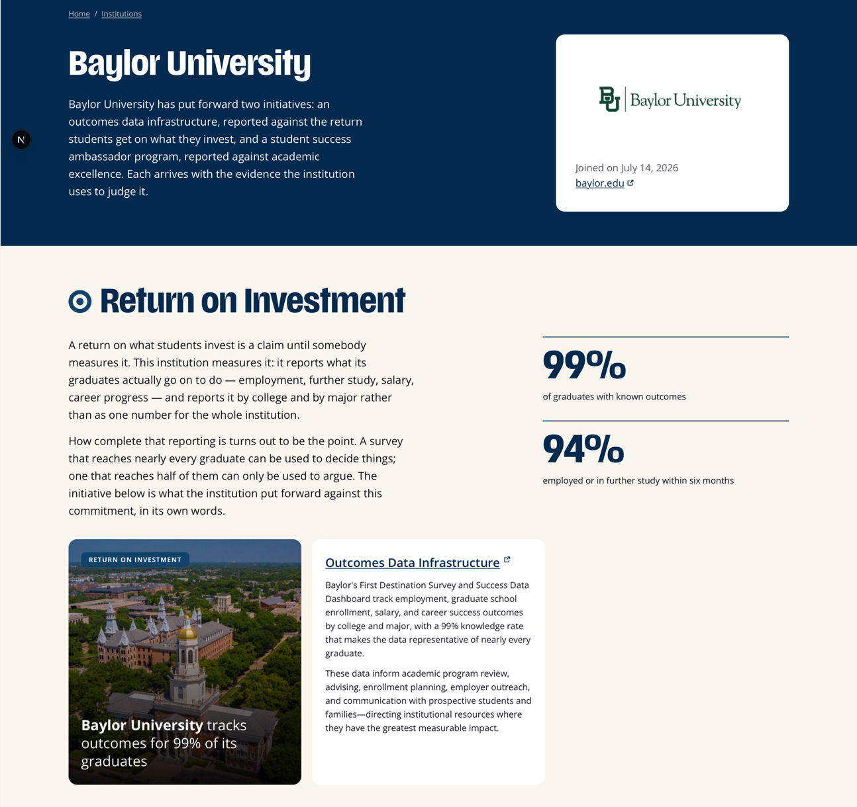
What it is | From Example | Your Response
Institution Name | Baylor University | [enter text]
Institution Logo | (image) | [enter text]
Institution Description | Baylor University has put forward two initiatives: an outcomes data infrastructure, reported against the return students get on what they invest, and a student success ambassador program, reported against academic excellence. Each arrives with the evidence the institution uses to judge it. | [enter text]
Link | baylor.edu | [enter text]
Joined on | [Date] | [enter text]

Commitment Areas
Institution profiles may include context describing how the institution supports each of the primary commitment areas. Related commitment stories will appear beneath the corresponding area. To provide this context, complete the table below. For multiple commitment areas, copy and paste the table and complete a separate version for each area. If no contextual overview is provided for an area with associated stories, the website will display the stories without an introductory description.

What it is | Example | Your Response
Commitment | Return on Investment | Choose an item.
Results Description | A return on what students invest is a claim until somebody measures it. This institution measures it: it reports what its graduates actually go on to do — employment, further study, salary, career progress — and reports it by college and by major rather than as one number for the whole institution.  How complete that reporting is turns out to be the point. A survey that reaches nearly every graduate can be used to decide things; one that reaches half of them can only be used to argue. The initiative below is what the institution put forward against this commitment, in its own words. | [enter text]
Key Figures (optional) | - 99% of graduates with known outcomes  - 94% employed or in further study within six months | [enter text]

TEMPLATE 2: Commitment Stories
Below is an example commitment story illustrating how submitted content will appear on the website. Review the example, then complete the table that follows for each story you would like to contribute. We invite you to submit multiple stories and populate multiple commitments to demonstrate your breadth--to submit multiple stories, copy and paste the table and complete a separate version for each story.

Example Commitment Story
What it is | Example
How it looks on the site
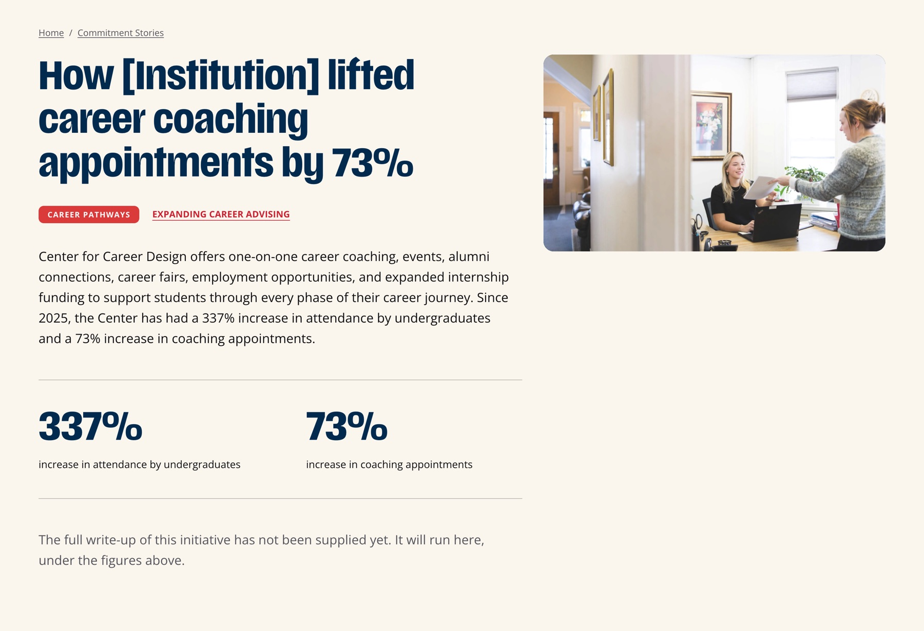
Commitment Area and Sub Area | Career Pathways  Expanding Career Advising
Headline | How [Institution] lifted career coaching appointments by 73%
Summary  On the tile when hovered, and at the top of the story page. Cuts off at about 160 characters. | Center for Career Design offers one-on-one career coaching, events, alumni connections, career fairs, employment opportunities, and expanded internship funding to support students through every phase of their career journey. Since 2025, the Center has had a 337% increase in attendance by undergraduates and a 73% inc Choose an item. rease in coaching appointments.
Full Description  This section can be quite robust and take up the bulk of the page. In the mockups, this area is currently empty, but the intent is to provide much more context about how that institution is meeting that commitment. | The full write-up of this initiative has not been supplied yet. It will run here, under the figures above.
Key figures (optional) | - 337% increase in attendance by undergraduates  73% increase in coaching appointments
Image Suggestion | A woman handing a paper to someone working at a desk.

Your Commitment Stories
Please copy and paste the table below and complete a separate version for each commitment story you would like to submit.

What it is | Your Response
Commitment Area and Sub Area | Choose an item.  Sub Area:
Headline | [enter text]
Summary  This summary is shown on the tile when hovered, and at the top of the story page. Cuts off at about 160 characters. | [enter text]
Full Description  This section can be quite robust and take up the bulk of the page. In the mockups, this area is currently empty, but the intent is to provide much more context about how that institution is meeting that commitment. | [enter text]
Key figures (optional) | [enter text]
Image Suggestion | [enter text]

